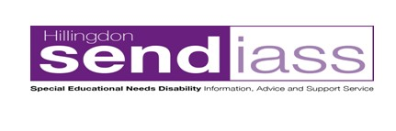
Hillingdon Special Education Needs and Disabilities Information, Advice and Support Service (SENDIASS) offers free, impartial, and confidential information, advice, and support. We aim to empower and enable parents/carers to be able to take an active role in decisions made about their child/young person regarding their education. Our drop-in sessions are for parents/carers to ask questions and share experiences.
Drop-in sessions 9-11am Barra Hall in Hayes,
Woodend Green Road, Hayes, UB3 2SA
9th June - Friday
10th July - Monday
11th August - Friday
4th September – Monday
Drop-in sessions 12.30 – 2pm Nestles Avenue children’s Centre.
Nestle Avenue, Hayes, UB3 4QA
5th July - Wednesday
Drop-in sessions 9-11am Uxbridge Childrens Centre Family Hub
Civic Centre (inside), High Street, Uxbridge, UB8 1UW
10th August – Thursday
24th August - Thursday
Please use the link below to register with the setting before attending, you will be asked to sign in. You do not need to print, please just register electronically. Do not worry about the age of your child when registering for these drop ins, all parent/carers of children and young people 0-25 welcome.
https://www.hillingdon.gov.uk/article/7409/Hillingdons-childrens-centres-Registration-form

