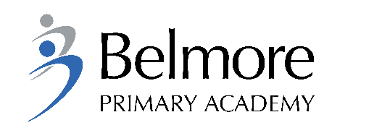
RECRUITMENT MONITORING

Belmore Primary Academy is committed to ensuring that applicants are selected based on their abilities relevant to the job. Completion of this section will help us to ensure that our policy and procedures are effective in avoiding discrimination and promoting equal opportunities in recruitment. The information you provide will be used for monitoring and statistical data purposes only and will not be seen by the short-listing panel.
Your Information
Position Applied For
Reference (if applicable)
Gender | Male Female Prefer not to say
Date of birth | DD / MM / YYYY

Ethnic Group – To which of these ethnic groups do you belong? (This is not a question about your nationality or place or birth, but your ethnic origins) PLEASE CIRCLE ONLY ONE OPTION
White | British / English / Welsh / Scottish / Northern Irish / Irish / Gypsy or Irish Traveller / Other
Mixed Groups | White & Black Caribbean / White & Black African / White & Asian / Other
Asian / Asian British | Indian / Pakistani / Bangladeshi / Chinese / Other
Black / Black British | African / Caribbean / Somali / Other
Other Ethnic Group | Arabic / Other / Prefer not to say

Religion | Sikh / Buddhist / Christian / Hindu / Humanist / Jewish / Muslim / Not Religious / Other / Prefer not to say
Sexual Orientation | Heterosexual / Straight / Bisexual / Gay Man / Gay Woman / Lesbian / Other /  Prefer not to say
Age Band | 16-24 / 25-34 / 35-44 / 45-54 / 55-64 / over 65

Disability - The Equality Act (2010) defines a disabled person as someone with a 'physical or mental impairment which has a substantial and long-term adverse effect on his/her ability to carry out normal day-to-day activities.'
To see if this applies to you, please visit: www.gov.uk/browse/disabilities
Do you consider yourself to have such a disability? | Yes No

Advertising Monitoring
Where did you see this job advertised?
Are you an internal or external candidate?
Please send this form with you’re the relevant application form in the post to the school or email to Mrs G Nagah gnagah@belmore.school

